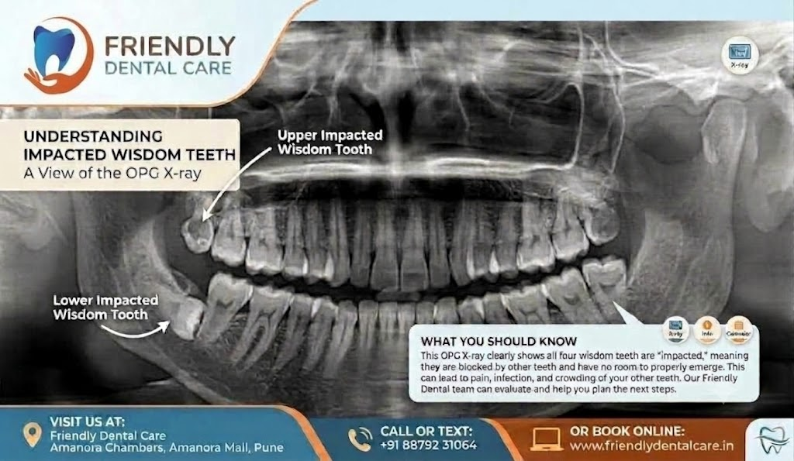

🦷 Is Your Wisdom Tooth “Stuck”? Don’t Ignore It!
Wisdom teeth don’t always emerge normally. When there isn’t enough space, they can become impacted—partially or completely trapped beneath the gum or bone.
🔍 An OPG X-ray can help identify:
• Impacted or tilted wisdom teeth
• Position and direction of growth
Potential problems with neighbouring teeth
• Whether treatment or removal may be needed
⚠️ Impacted wisdom teeth may cause:
Pain • Swelling • Infection • Food trapping • Damage to nearby teeth
👉 Don’t wait for pain to decide. A dental evaluation and X-ray can help you understand what’s happening and plan the right treatment.
📍 Friendly Dental Care
326, Amanora Chambers, Amanora Mall, Pune
📞 88792 31064
🌐 www.friendlydentalcare.in
Your wisdom teeth may be silent—but an X-ray can tell the story.

